Chiyoung Jeffrey Lii

Clii01@syr.edu

Stock and Technical Analysis Database

A quick and reliable trading resource

# Project Summary

The purpose of this project is to provide information management to financial traders. There are several datatypes traders much take into consideration every day, such as the open and close prices, the ten-day Exponential Moving Average (EMA), and the results of their trades. The process of handling and organizing this data is both tedious and prone to human error and when a single wrong digit can result in the loss of a few thousand dollars, data management must be done correctly.

This database will record the opening, closing, highest, and lowest prices of a trading day, as well as three technical indicators, the EMA, Moving Average Convergence Divergence (MACD), and the Bollinger Bands (BBANDS). Finally, the database will also keep track of past strategies, and their success rates. This will allow traders to iterate and improve on their strategies.

The database can be separated into two sections, connected by a ticker table that indicates which ticker symbol is being analyzed. The ‘Daily Data’ section contains information that traders can use to trade, such as the lowest price over the last 100 days (good price point to buy) and whether the stock is overbought or oversold (to know when to avoid buying or selling). The ‘Recommendation’ section of the database is to allow traders to track the efficiency of their strategies. Each strategy will have multiple versions (so traders can improve), and each version will have a test result associated with it (to see how well it did).

The main advantage of using this database is that traders will be able to write programs to implement strategies in a quantitative manner. For example, while it is difficult to see what the lowest price of the last 100 days are on a chart, it is very simple to write a select statement in a SQL database.

The following document contains a table of entities and attributes that will be in the database, as well as an entity relationship diagram relating the respective entities to each other. Finally, it contains a list of business rules not already covered by the table and diagram, as well as a list of business questions to be answered

# Entity and Attribute Table

|  |  |
| --- | --- |
| Objects | Description |
|  |  |
| 1. **Ticker** | Represents an abbreviation used to uniquely identify publicly traded shares of a particular stock on a particular stock market. |
| 1. Ticker_key | Surrogate primary key for the ticker entity |
| 1. Ticker_symbol | The abbreviation of the stock |
|  |  |
|  |  |
| 1. **Daily_Data** | Data of a particular day |
| 1. Daily_data_key | Surrogate primary key for the daily data entity |
| 1. Ticker_key | Ticker the data is about |
| 1. Day | Day the data is on |
|  |  |
| 1. **Time_Series_Daily** | Times series data of a particular day |
| 1. Daily_Data_Key | Which day the time series data is on |
| 1. Time_series_daily_key | Surrogate primary key for the time series daily entity |
| 1. Open | Opening price of the stock on that day |
| 1. High | Highest price of the stock on that day |
| 1. Low | Lowest price of the stock on that day |
| 1. Close | Closing price of the stock on that day |
|  |  |
| 1. **EMA** | The 10 day exponential moving average of a stock price on a particular day |
| 1. Daily_data_key | Which day the EMA data is on |
| 1. Ema_key | Surrogate primary key for the EMA entity |
| 1. Ema | EMA value for the day (in numbers) |
|  |  |
| 1. **MACD** | The Moving Average Convergence Divergence of a stock price on a particular day |
| 1. Daily_Data_Key | Which day the MACD data is on |
| 1. Macd_key | Surrogate primary key for the MACD entity |
| 1. Macd_Hist | Macd histogram value on that day. The difference between the macd and the signal line. |
| 1. Macd_signal | Signal line used to determine macd_hist. Using the 9 day EMA. |
| 1. Macd | The MACD value. Currently using the difference between the 26 period and 12 period EMA. |
|  |  |
| 1. **BBANDS** | The Bollinger Band data for a stock on a particular day |
| 1. Bbands_key | Surrogate primary key for the BBANDS entity |
| 1. Daily_Data_Key | Which day the BBANDS data is on. |
| 1. Real_Middle_Band | The value the BBANDS originate from |
| 1. Real_Upper_Band | Two standard deviations above the middle band |
| 1. Real_Lower_Band | Two standard deviations below the middle band. |
|  |  |
| 1. **Backtest_Results** | Results of a backtest |
| 1. Backtest_Results_Key | Surrogate Primary Key of the backtest results entity |
| 1. Recommendation_version_key | Version of the strategy being tested |
| 1. Ticker_key | Ticker of the stock being tested |
| 1. Date_tested | Day the test was run |
| 1. Biggest_lost | Biggest lost found during the test |
| 1. Successes | Number of successes found during test |
| 1. Failures | Number of failures found during test |
| 1. Fizzles | Instances of signals that are neither success or failures |
| 1. Total | Total signals discovered during backtest |
| 1. Percent_success | Percent of success signals found during backtest |
| 1. Percent_not_failed | Percent of success + fizzle signals found during backtest |
|  |  |
| 1. **Recommendation_Version** | A version of a recommendation strategy |
| 1. Recommendation_version_key | Surrogate Primary Key for the Recommendation Version entity |
| 1. Recommendation_Type_key | The type of Recommendation |
| 1. Version | Version number of recommendation strategy |
|  |  |
| 1. **Recommendation_Type** | A Recommendation Strategy |
| 1. Recommendation_Type_key | Surrogate Primary Key for Recommendation Type entity |
| 1. Trend | Bearish or Bullish recommendation type |
| 1. Name | Name of recommendation strategy |
| 1. Days_To_Hold | Period to hold trade. Long term, short term |
| 1. Description | Short description of strategy |
|  |  |
|  |  |

# Relational Data Model

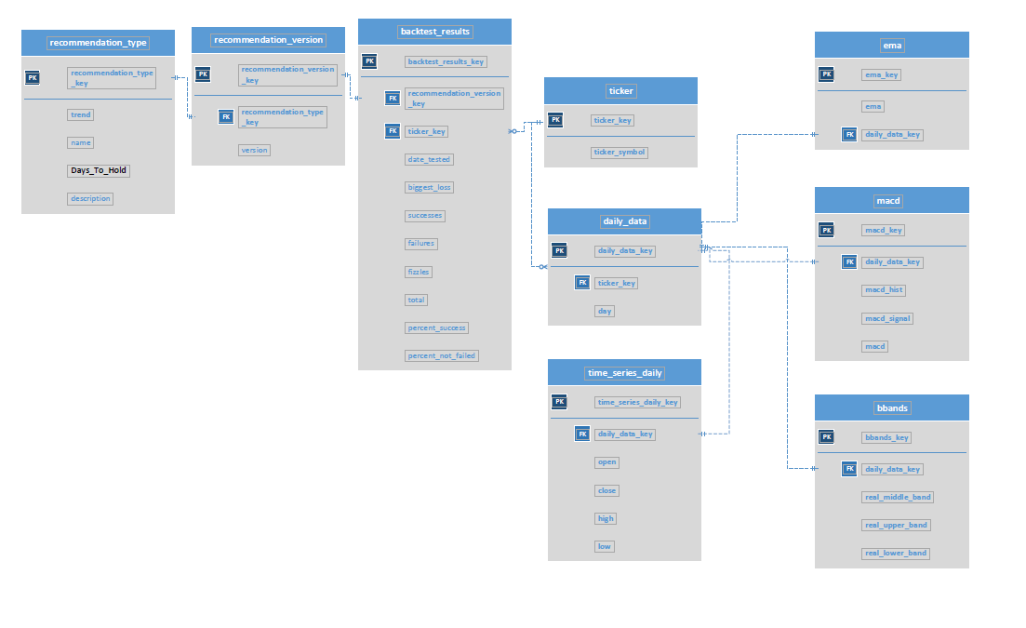

# Business Rules

1. There should only be one daily data row per day
2. Ticker symbols should be unique
3. Backtest results are for the last hundred days from the date tested
4. Backtest results are calculated using the daily data

# Data Questions

1. What is the lowest, highest, mean, median, and standard distribution of the stock price, and MACD over the last one hundred days?
2. Are the recommendation strategies improving by a statistically significant amount as the versioning increases?
3. When does the stock price drop above/below the Bollinger Bands?
4. When does the stock price cross the EMA?
5. What was the average MACD of the stock during the last 100 days